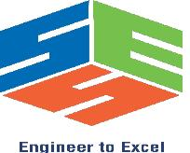

SIMATS ENGINEERING
Saveetha Institute of Medical and Technical Sciences
Chennai- 602105

Student Name: Devadharshini E Reg. No.: 192524483
Course Code: BTA 0158 Slot: B
Course Name: Biology and Environmental Science for Engineers
Course Faculty: Dr. Manikandan

Project Title: Earth5R Urban Waste Management Model in Mumbai and Bengaluru
Module Photographs: (3 photographs –Module Photo, Individual student contribution module work in the project and presentation image)

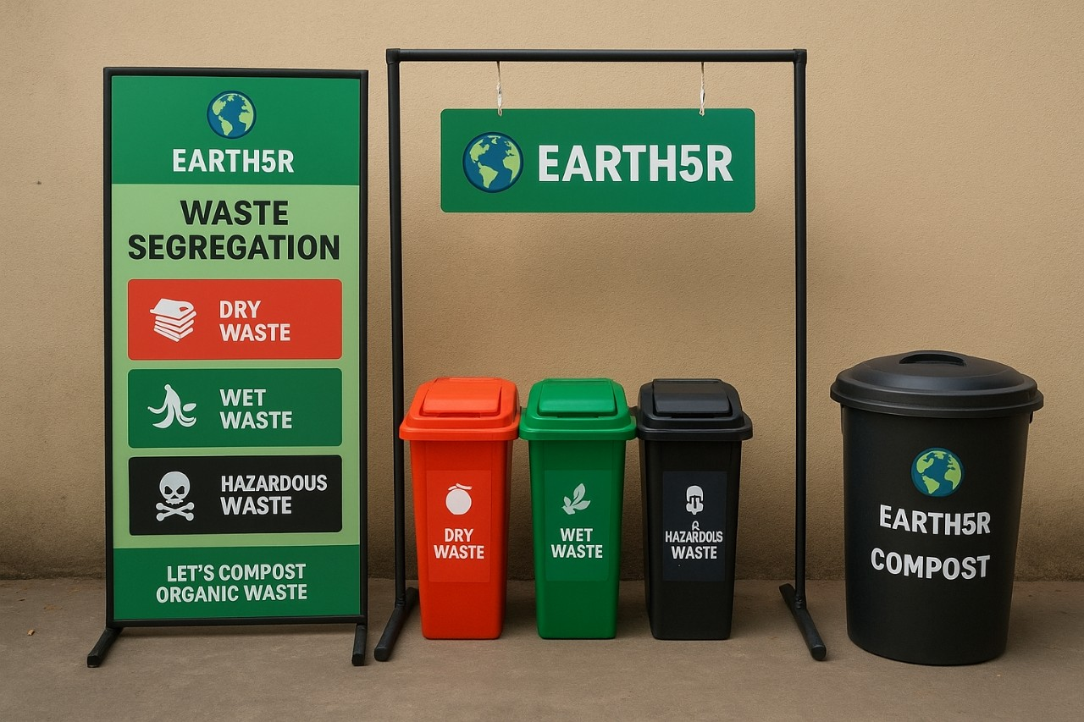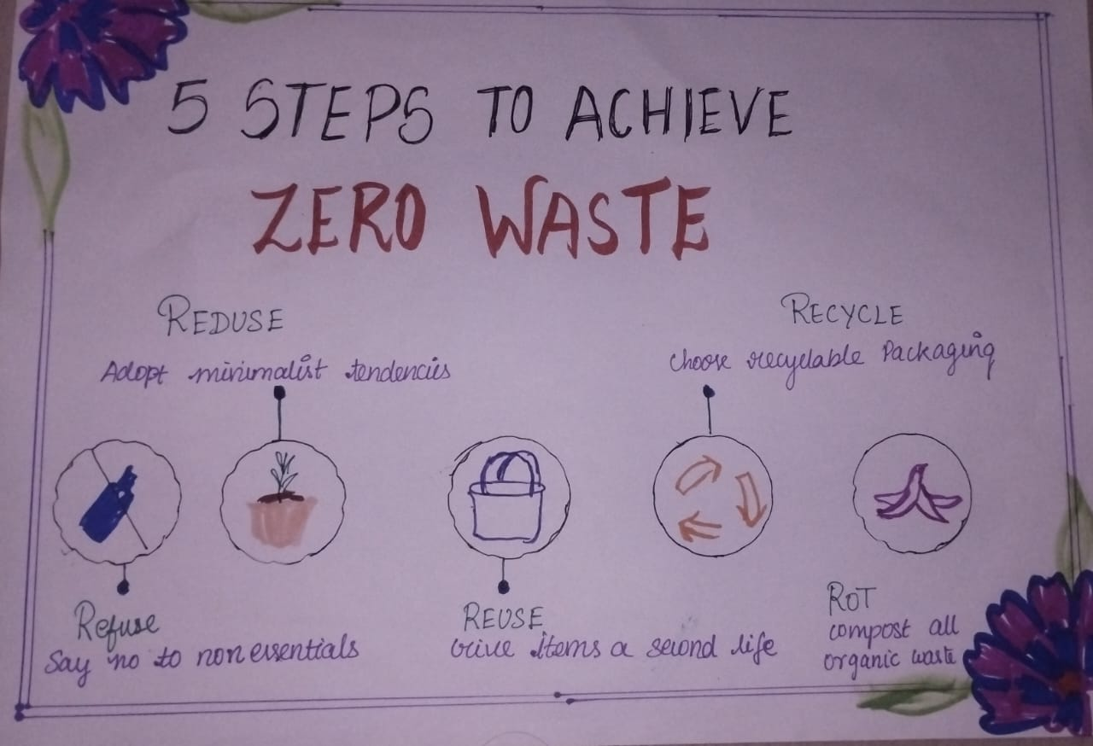
Project Description: (here you write what you did in this project (contribution) including Model Description
The Earth5R Urban Waste Management Model in Mumbai and Bengaluru promotes a circular economy through community participation, waste segregation, recycling, and upcycling. Using technology and decentralized systems, it reduces landfill waste, generates employment, and raises environmental awareness. The model demonstrates a sustainable, scalable solution for future urban waste challenges.

Student Signature Guide Signature

